IT030

Quiz 2 – Review

HTML Table: what is TR/TH

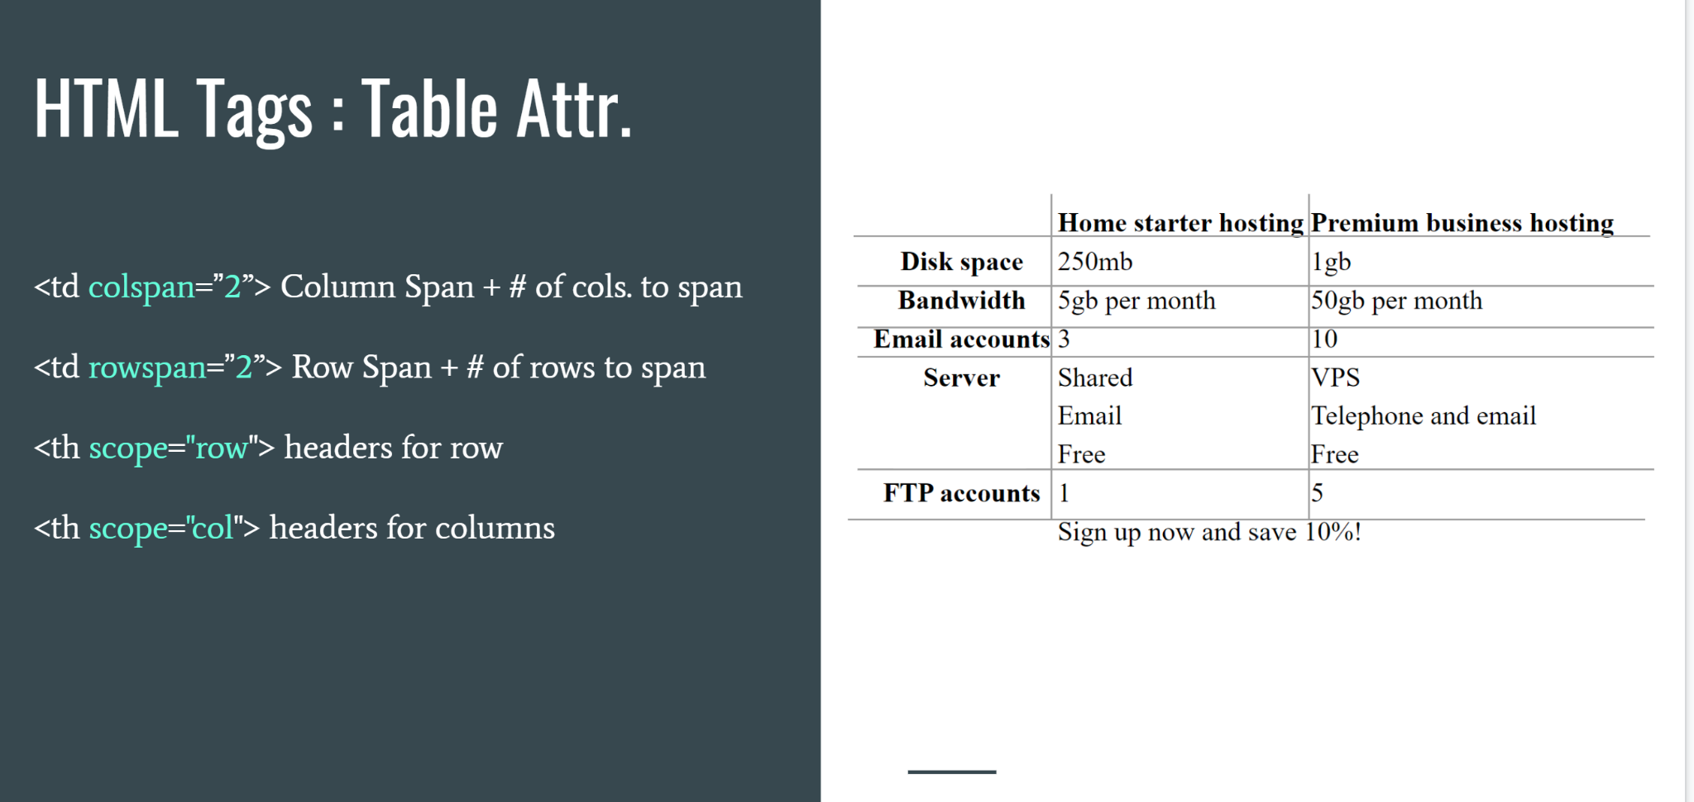

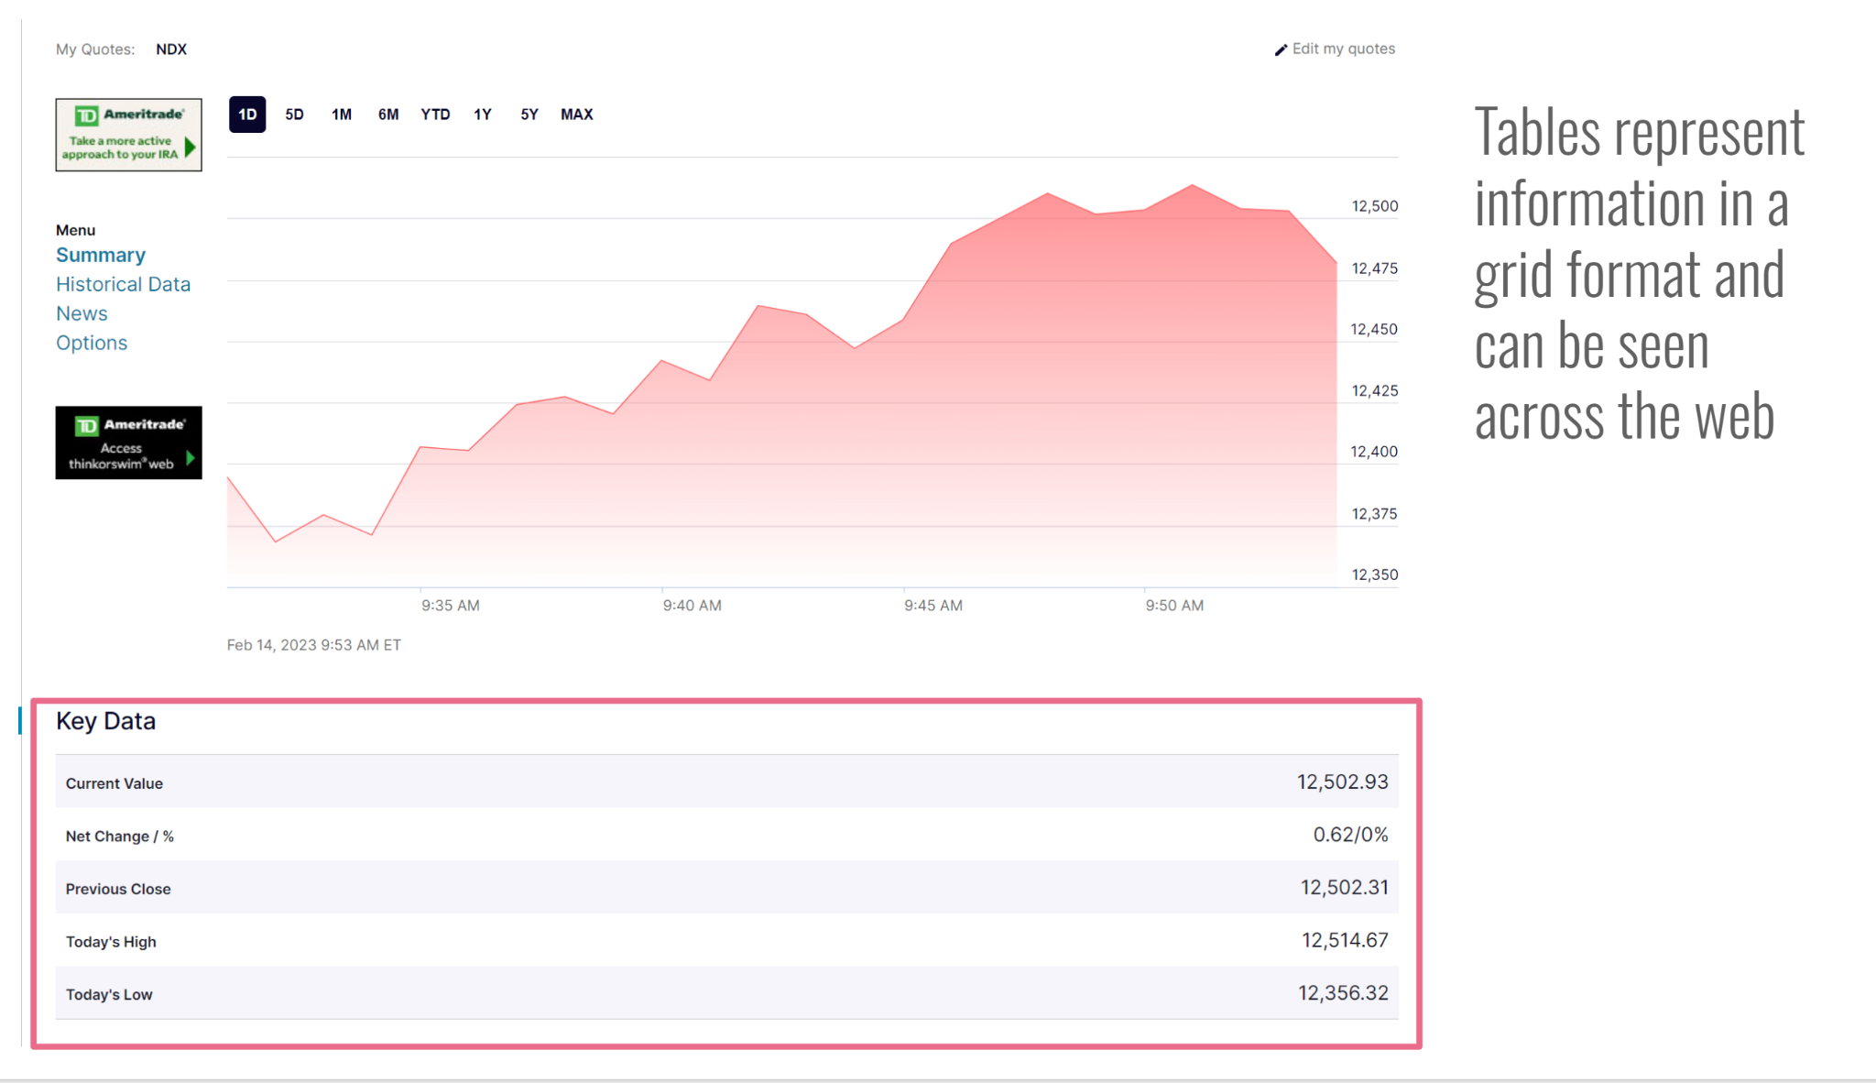

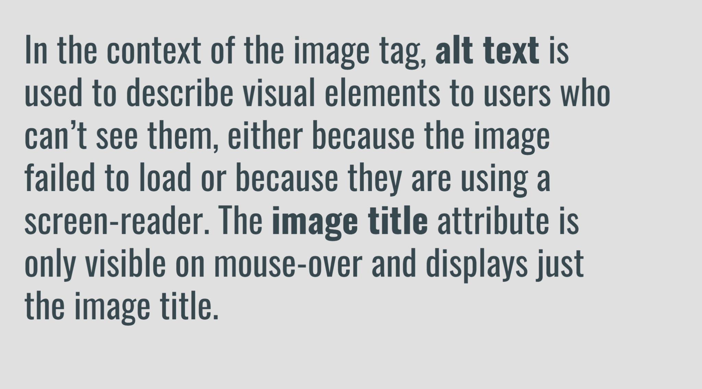

How to Comment using HTML

Iframes Syntax:

<iframe src="demo_iframe.htm" height="200" width="300" title="Iframe Example"></iframe>

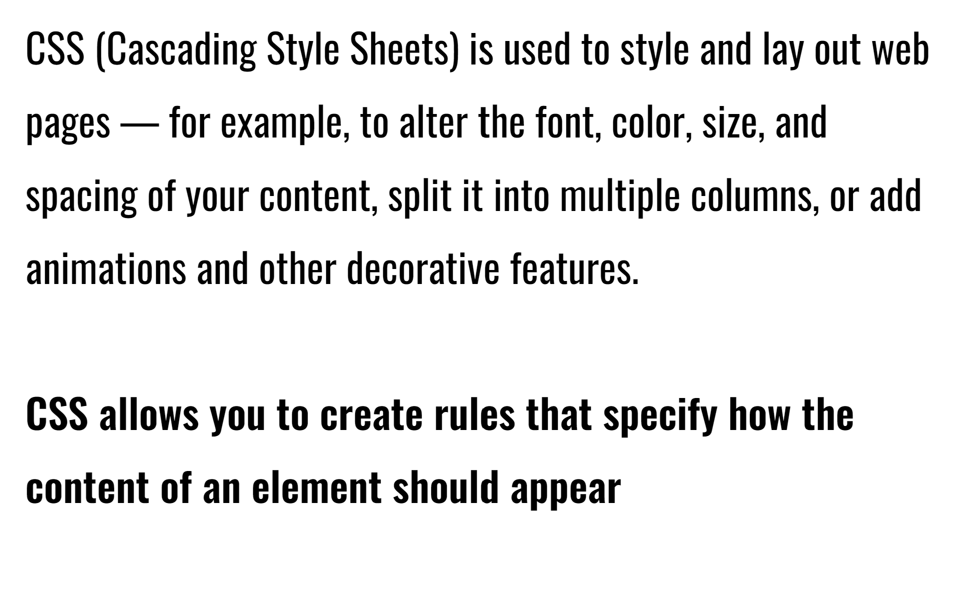

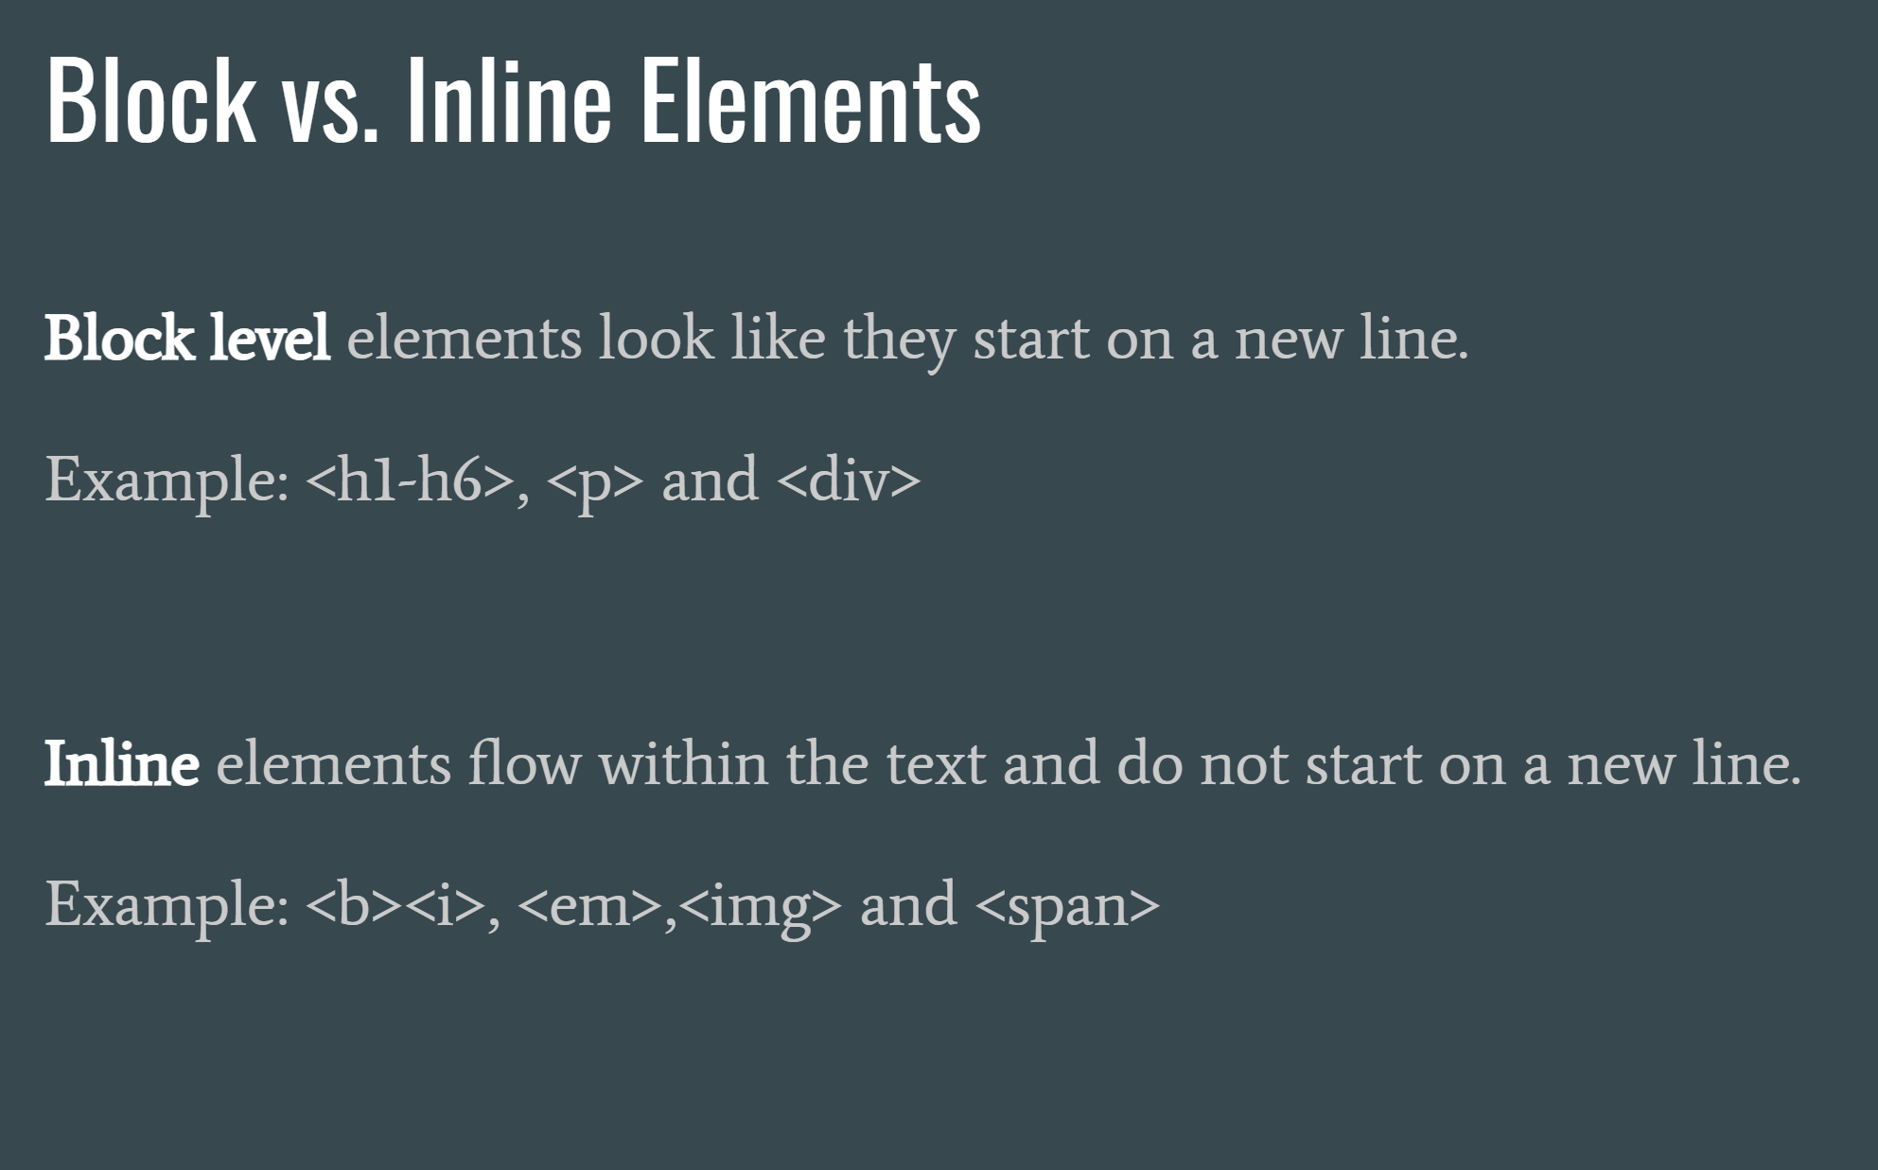

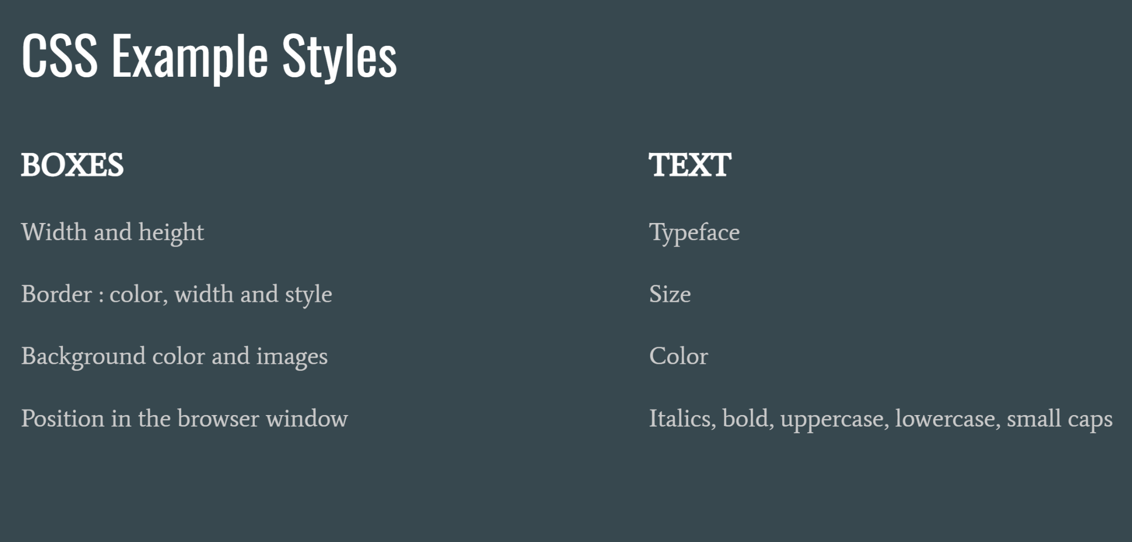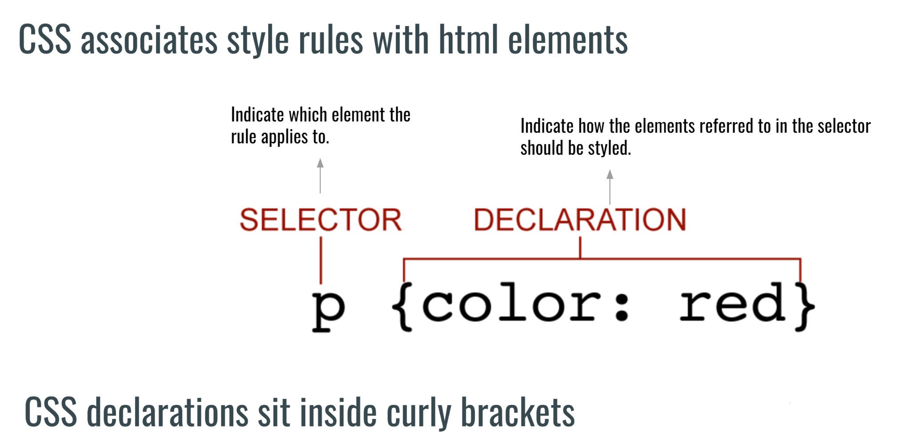

What are: Internal, External and Inline CSS, how are they referenced (called/used/etc.)

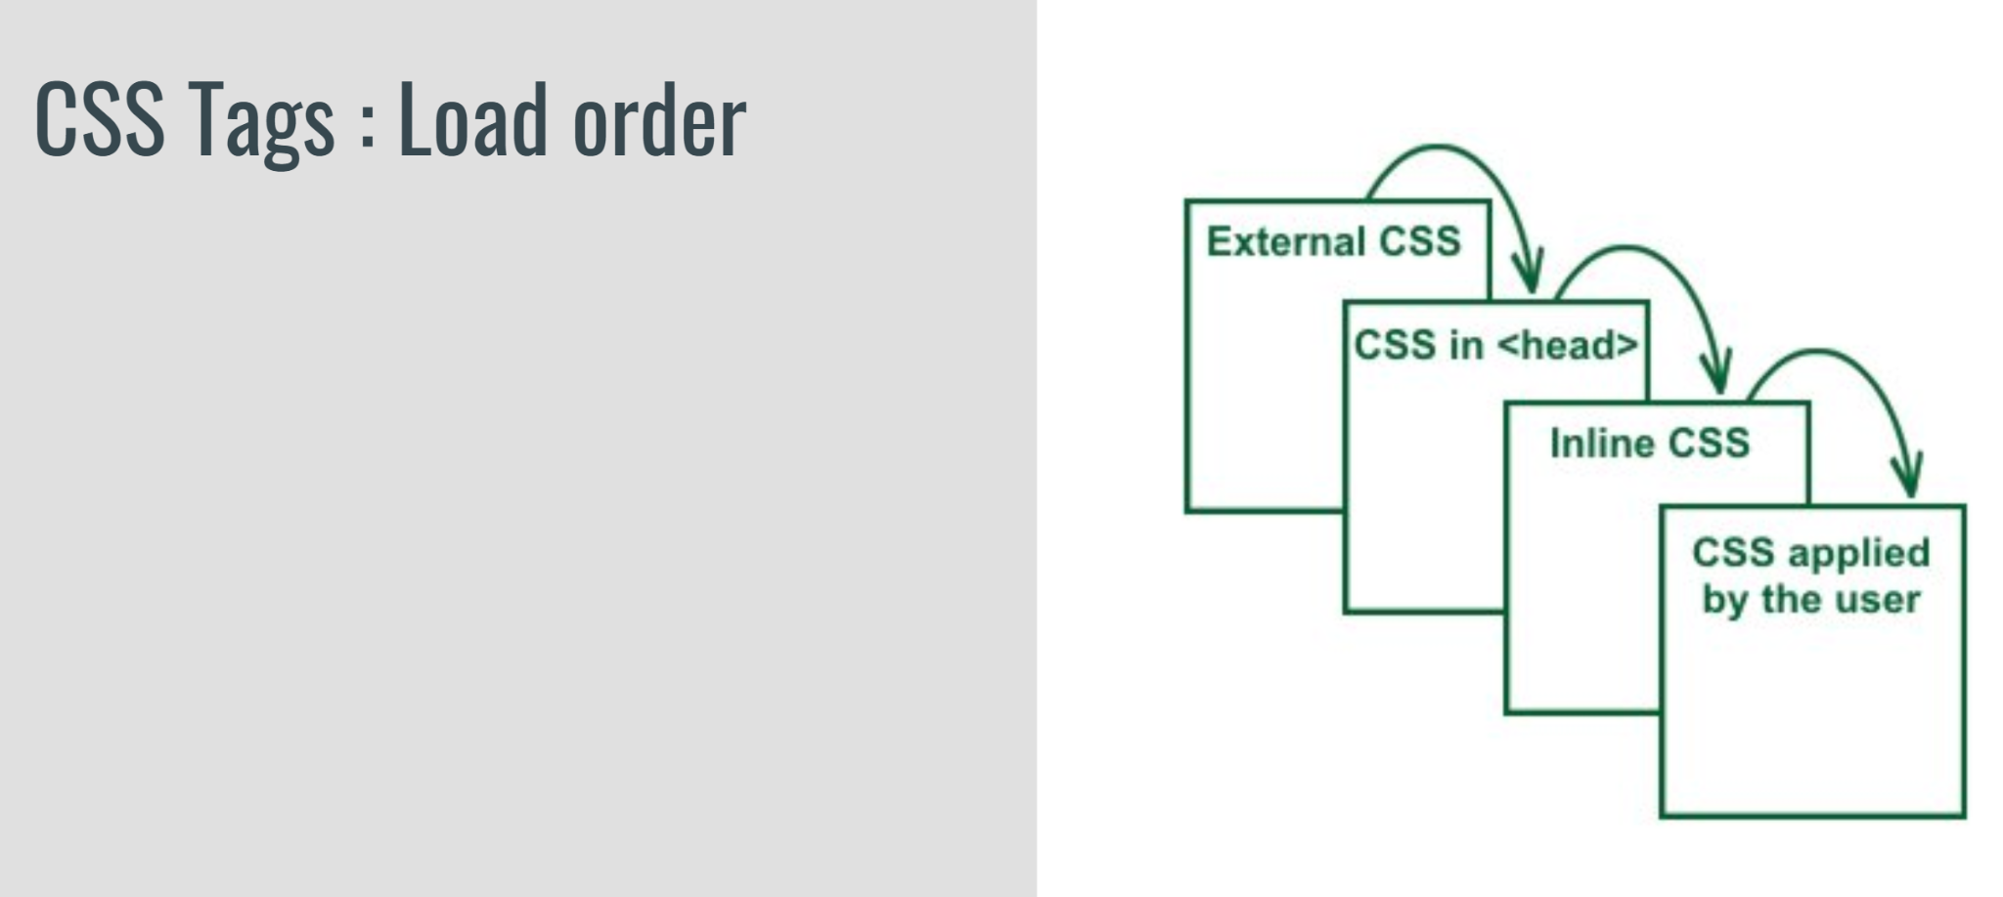

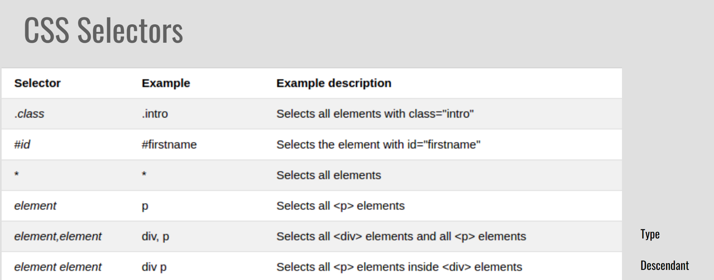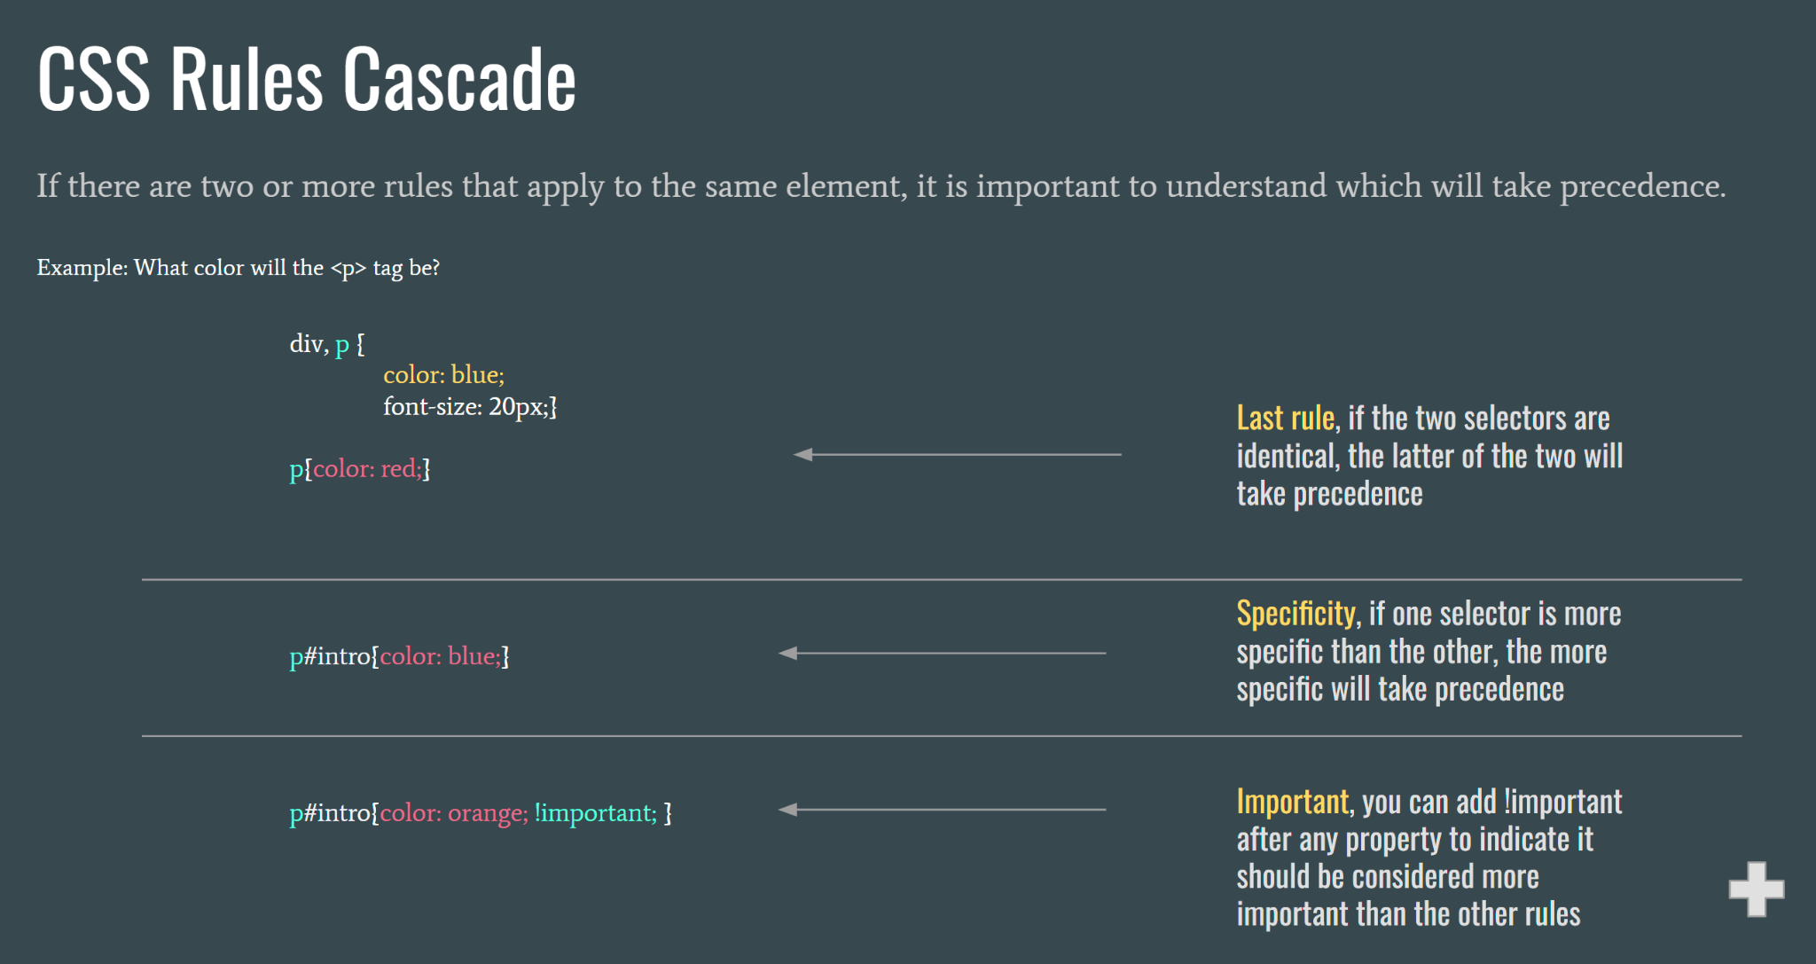

How css allows you to style fonts: Font style, font weight, text transform, and text decoration ← know the syntax, eg. how do you add an underline or change the weight of the font?

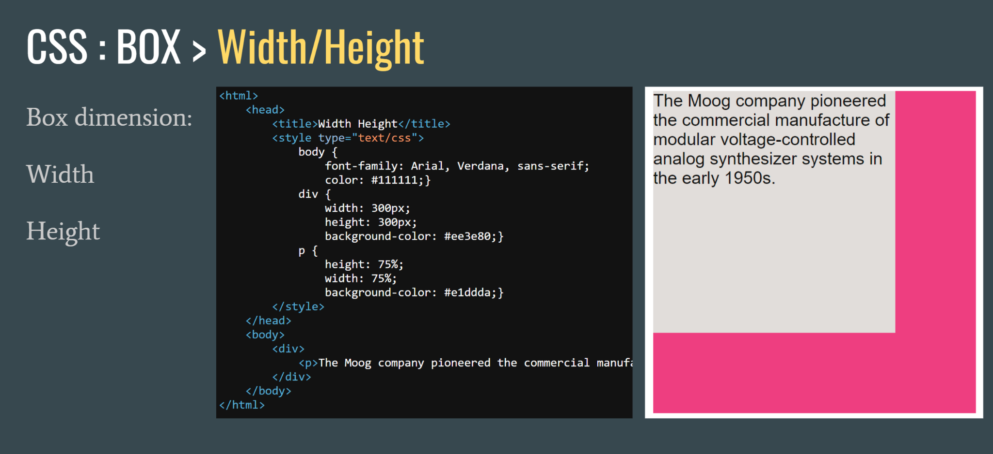

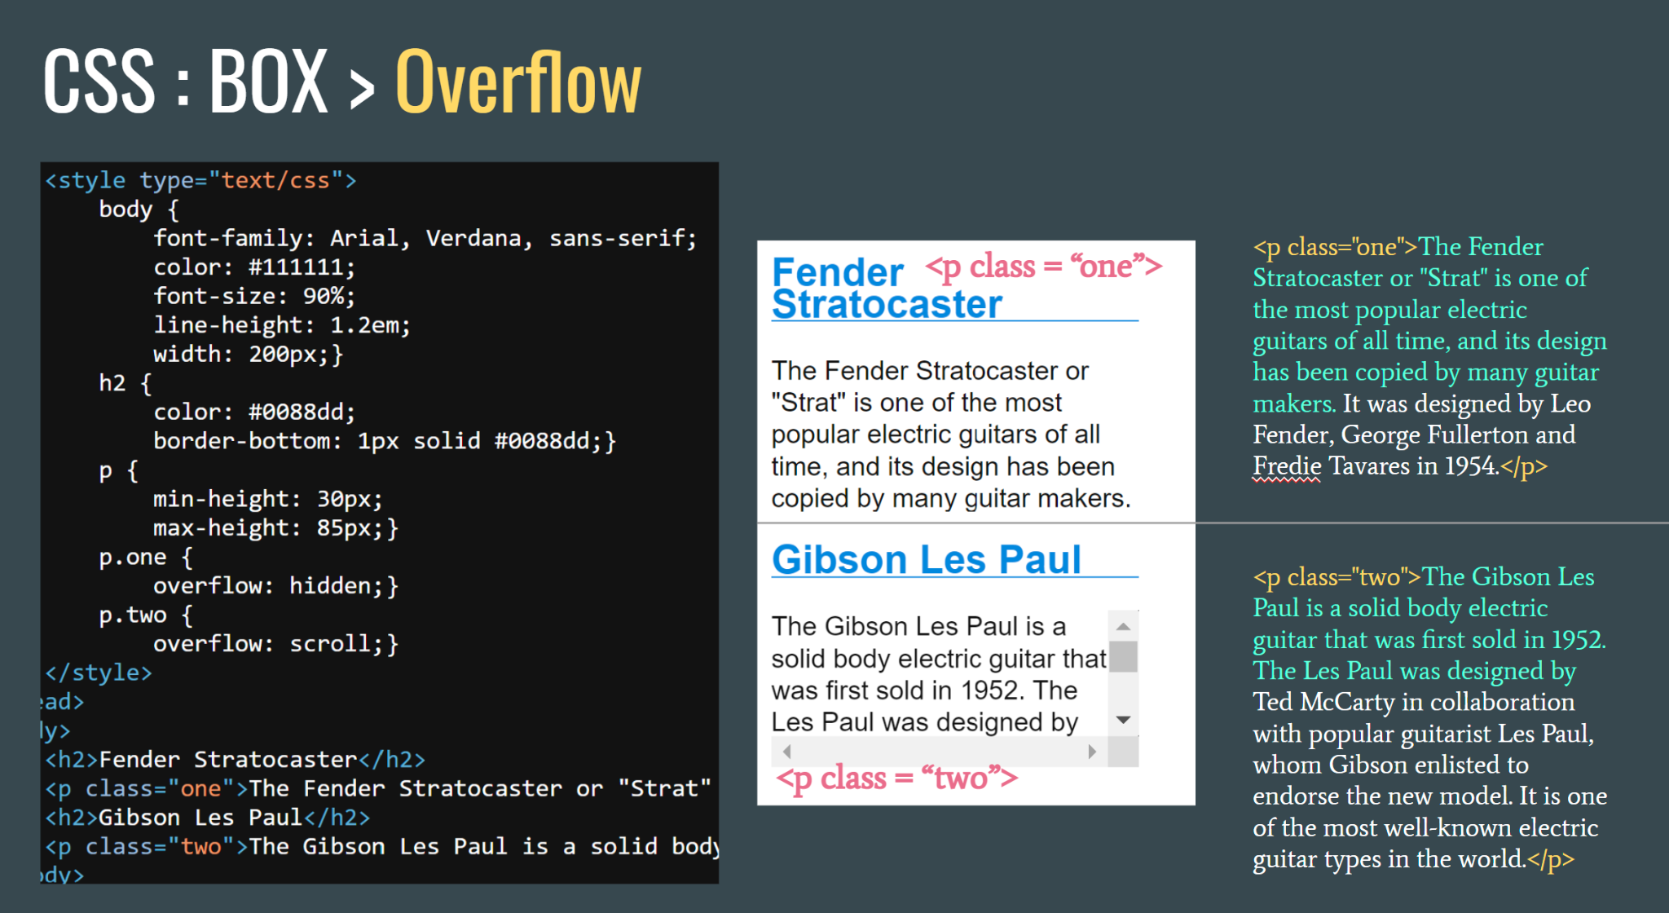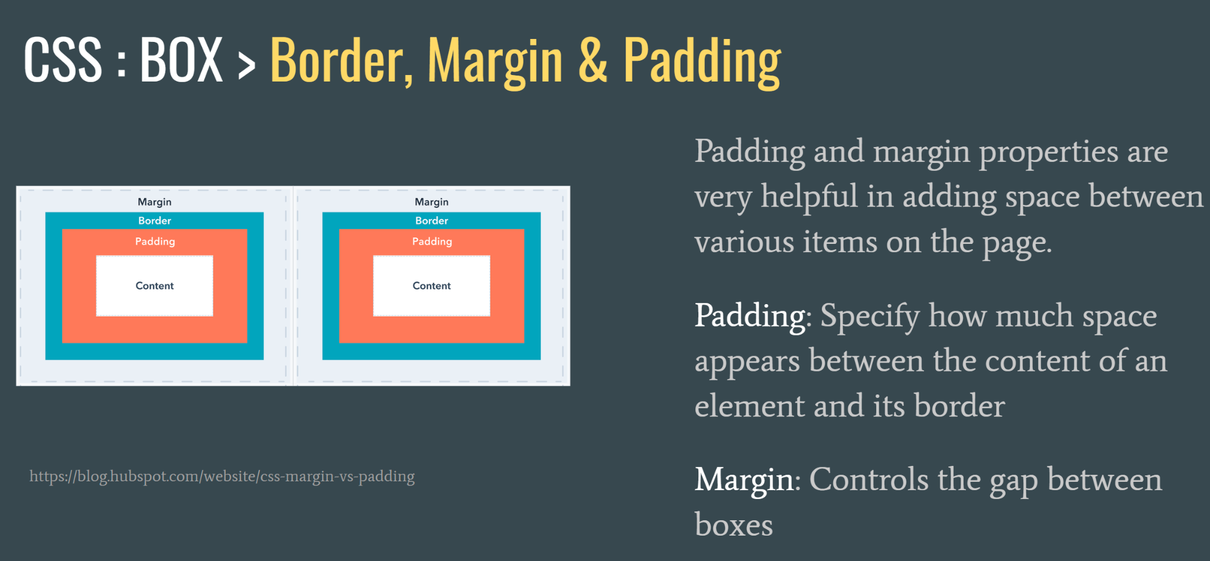

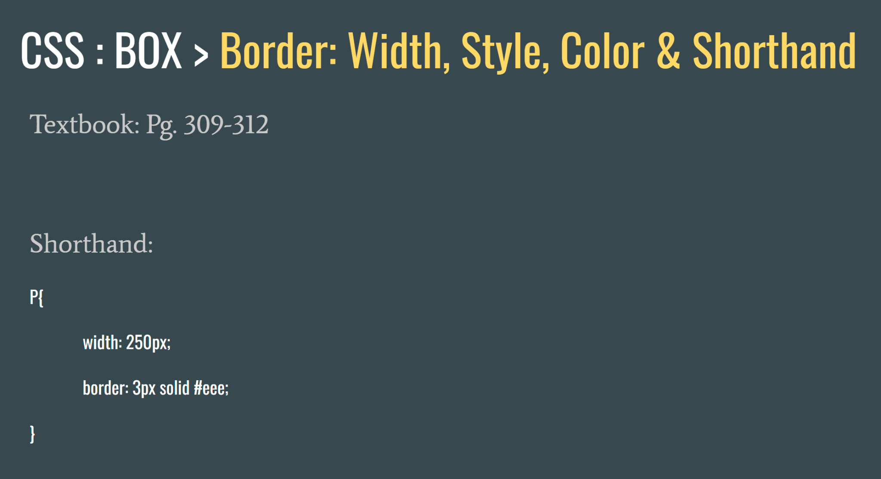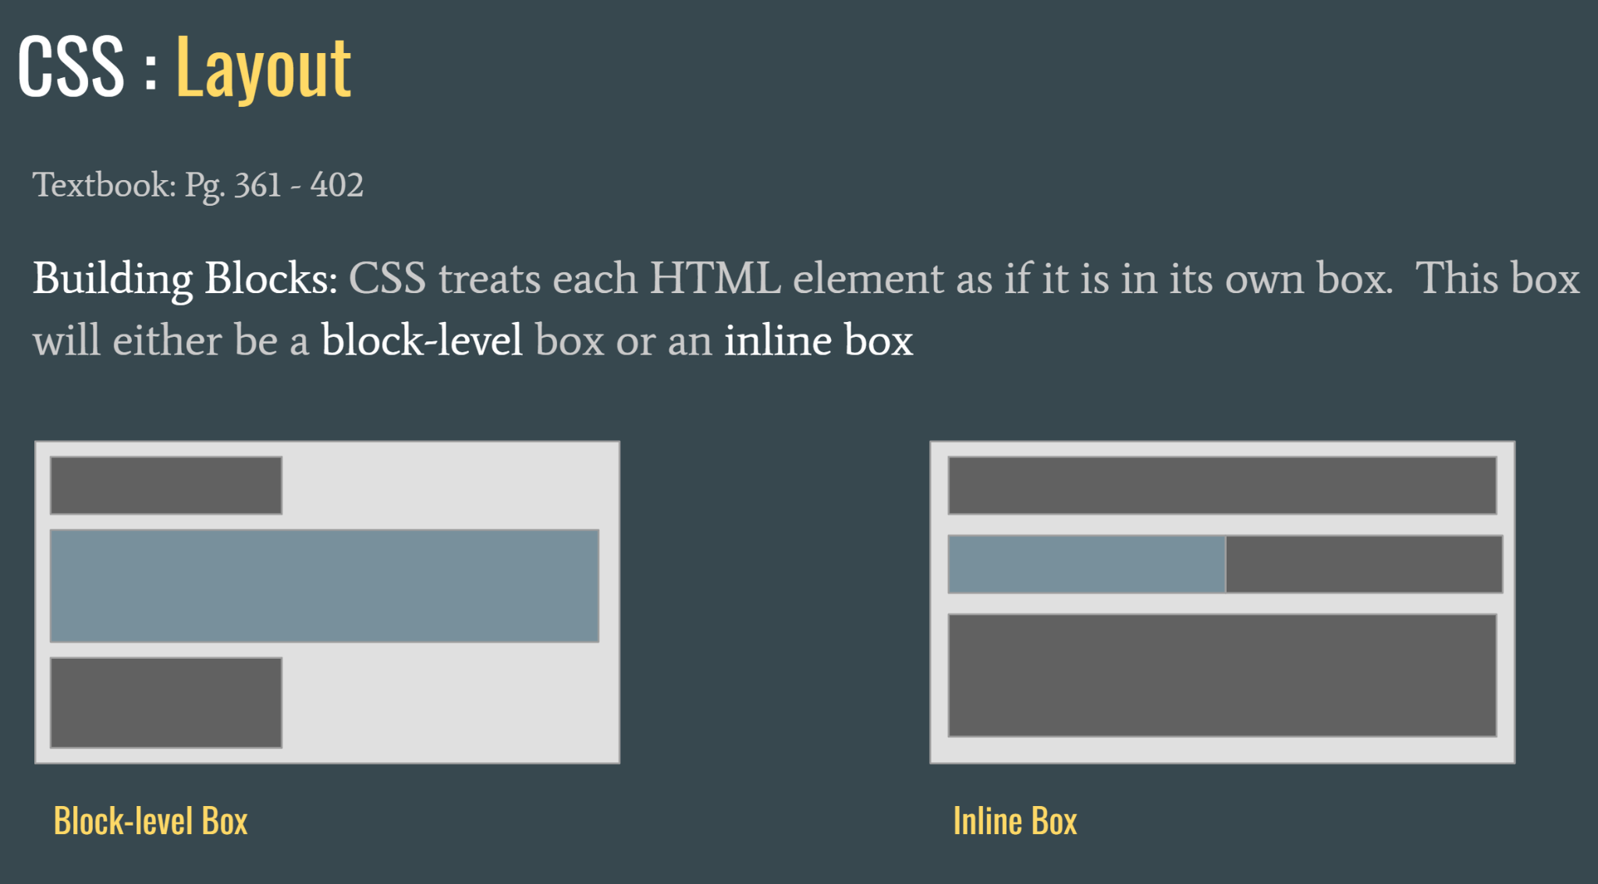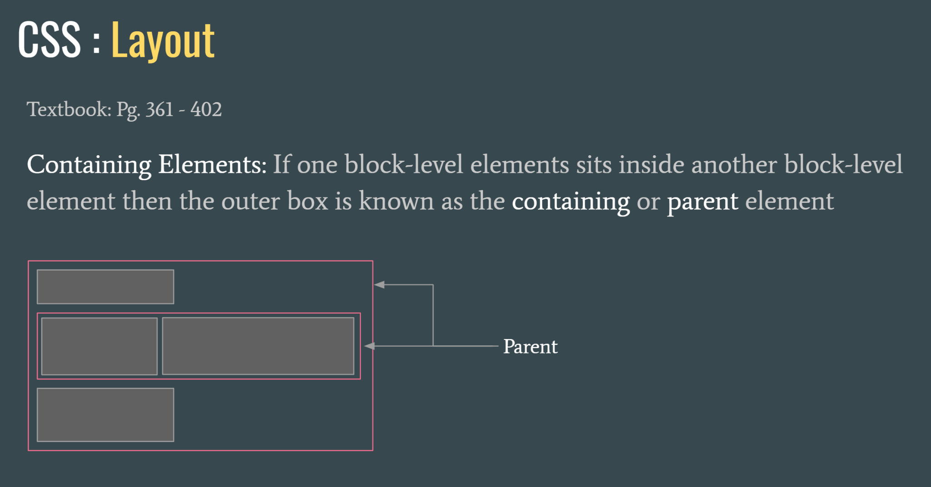

CSS Grid Layout (aka “Grid” or “CSS Grid”), is a two-dimensional grid-based layout system that, compared to any web layout system of the past, completely changes the way we design user interfaces.

Grid Gaps (Gutters)

The grid-column-gap and grid-row-gap properties create gutters between columns and rows.

All grids are made up of three elements: columns, gutters, and margins. Columns are the building blocks of a grid and mark where elements should be placed. Gutters are the negative space between columns and their width should be a multiple of the base unit. Margins are the negative space between the edge of the outside column and the frame.

Responsive Web design is the approach that suggests that design and development should respond to the user’s behavior and environment based on screen size, platform and orientation.

The practice consists of a mix of flexible grids and layouts, images and an intelligent use of CSS media queries.

Media queries in CSS3 extended the CSS2 media types idea: Instead of looking for a type of device, they look at the capability of the device.

The Flexbox Layout (Flexible Box) module .. aims at providing a more efficient way to lay out, align and distribute space among items in a container, even when their size is unknown and/or dynamic (thus the word “flex”).

The main idea behind the flex layout is to give the container the ability to alter its items’ width/height (and order) to best fill the available space (mostly to accommodate to all kind of display devices and screen sizes). A flex container expands items to fill available free space or shrinks them to prevent overflow.

Know what a grid template area is

.wrapper

{

display: grid;

gap: 20px; /* gutter*/

grid-template-areas:

"header"

"aside"

"section"

"footer";

}

Media queries can be used to check many things, such as:

width and height of the viewport

width and height of the device

orientation (is the tablet/phone in landscape or portrait mode?)

resolution

Using media queries are a popular technique for delivering a tailored style sheet to desktops, laptops, tablets, and mobile phones (such as iPhone and Android phones).

S